**LAB 5_Web Server (Monitor and Hardware)**

|  |  |
| --- | --- |
| Name : | Tran Le Minh Quan |
| Your student ID : | 22CE.B022 |

1. **Monitor:**

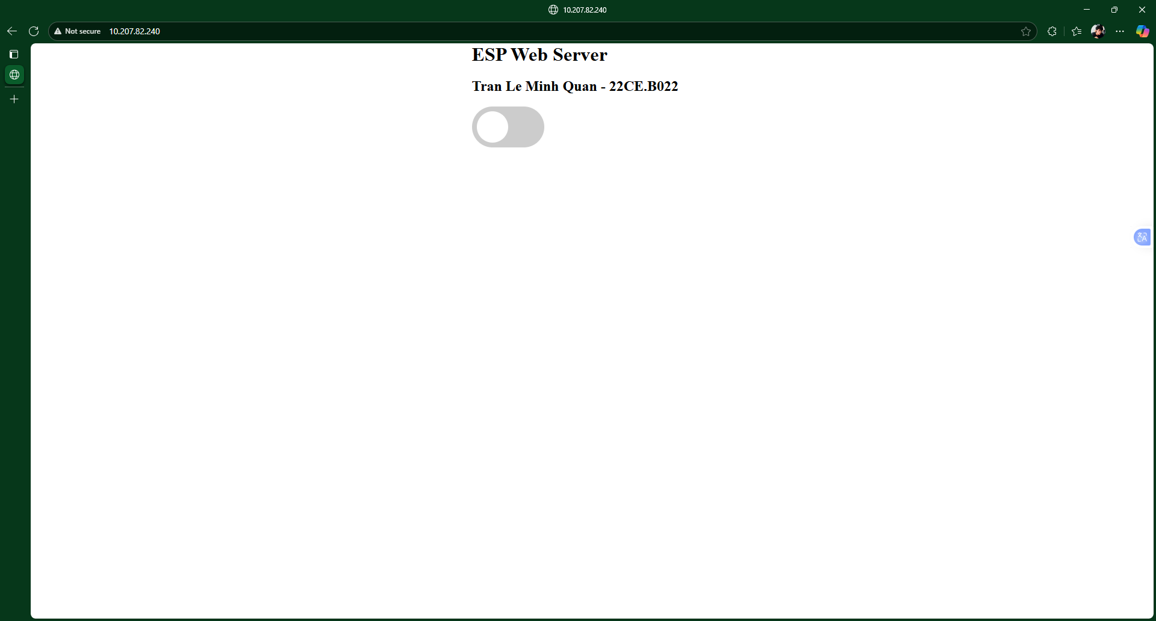

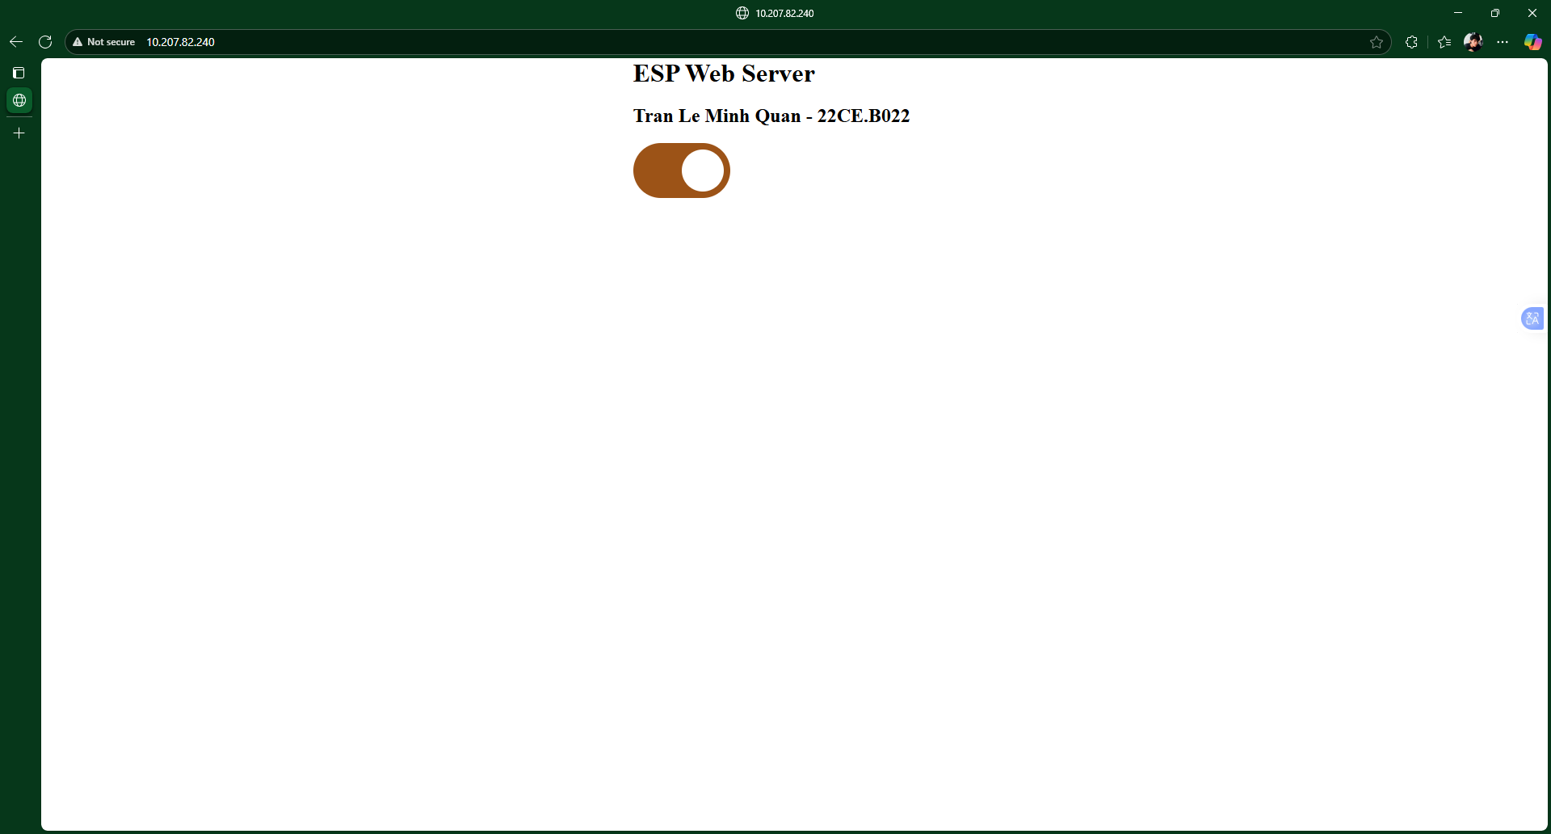

1. **Hardware:**

